Função S

Linha | X3 | X2 | X1 | X0 | s4 | s3 | s2 | s1 | s0
0 | 0 | 0 | 0 | 0 | 0 | 0 | 0 | 0 | 0
1 | 0 | 0 | 0 | 1 | 0 | 0 | 1 | 0 | 0
2 | 0 | 0 | 1 | 0 | 0 | 0 | 1 | 0 | 1
3 | 0 | 0 | 1 | 1 | 0 | 0 | 1 | 1 | 0
4 | 0 | 1 | 0 | 0 | 0 | 0 | 1 | 1 | 1
5 | 0 | 1 | 0 | 1 | 0 | 1 | 0 | 0 | 0
6 | 0 | 1 | 1 | 0 | 0 | 1 | 0 | 0 | 1
7 | 0 | 1 | 1 | 1 | 0 | 1 | 0 | 1 | 0
8 | 1 | 0 | 0 | 0 | 1 | 0 | 1 | 1 | 0
9 | 1 | 0 | 0 | 1 | 1 | 0 | 1 | 1 | 1
10 | 1 | 0 | 1 | 0 | 1 | 1 | 0 | 0 | 0
11 | 1 | 0 | 1 | 1 | 1 | 1 | 0 | 0 | 1
12 | 1 | 1 | 0 | 0 | 1 | 1 | 0 | 1 | 0
13 | 1 | 1 | 0 | 1 | 1 | 1 | 0 | 1 | 1
14 | 1 | 1 | 1 | 0 | 1 | 1 | 1 | 0 | 0
15 | 1 | 1 | 1 | 1 | 1 | 1 | 1 | 0 | 1

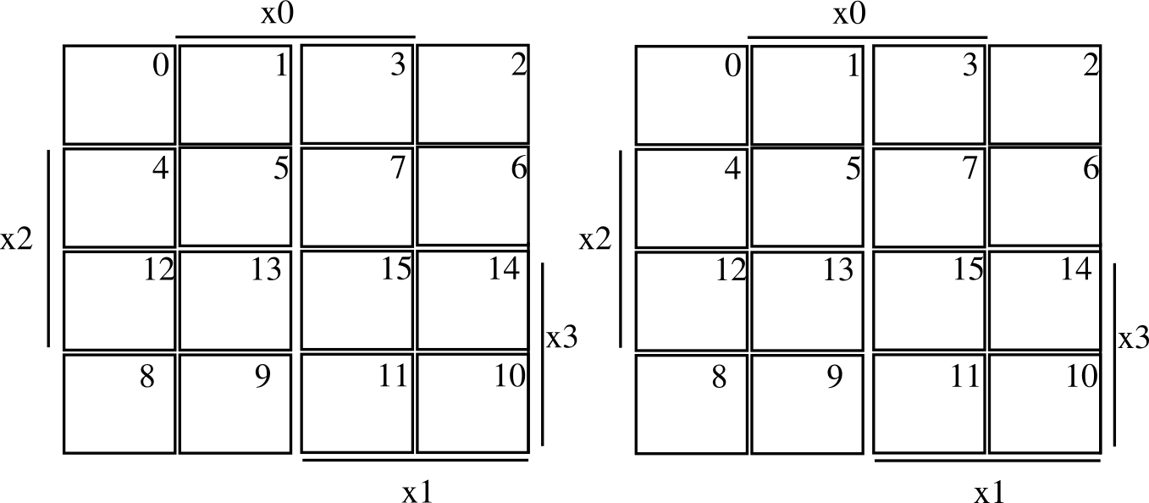

1
1
1

1
1
1
1
1
1
1
1

1
1
1
1
1
1

S4 = X3 S3 = X3 X2 | X3 X1 | X2 X1 | X2 X0

1
1
1
1

1
1
1

1
1
1
1

1
1
1
1

S2 = X2~X0~X1~X2 | X3~X2~X1 | S1 = X2~X1~X0 | X1 X0~X3 | X3~X1
X1~X2~X3 | X0~X2~X3 | X1 X2 X3

1

1
1

1
1

1
1

S0 = X2~X0~X3 | X1~X0~X3 | X3 X0

